Udayana University | INSTITUTE FOR LEARNING DEVELOPMENT AND QUALITY ASSURANCE UDAYANA UNIVERSITY
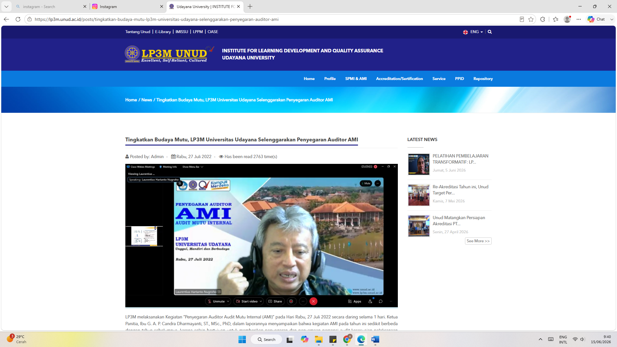
Udayana University | INSTITUTE FOR LEARNING DEVELOPMENT AND QUALITY ASSURANCE UDAYANA UNIVERSITY
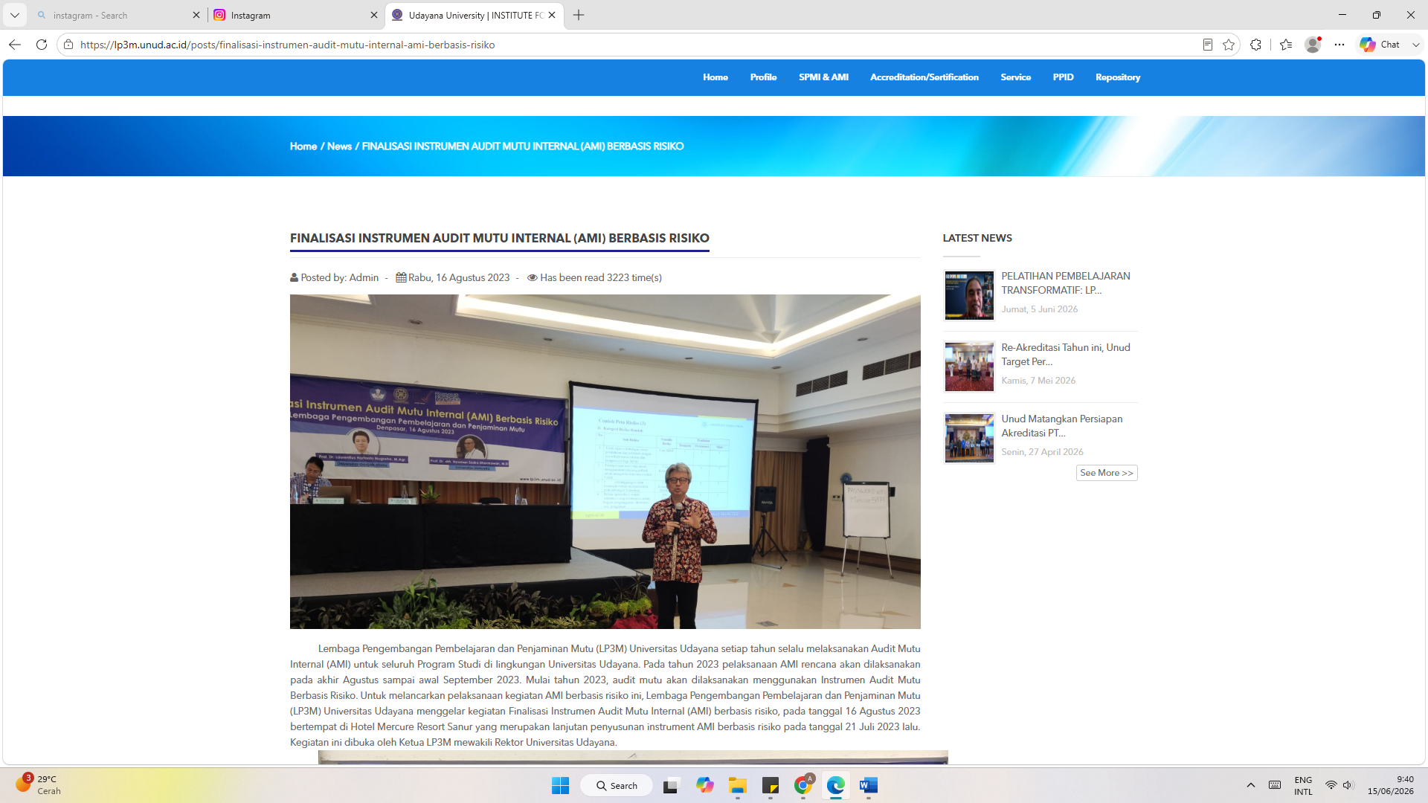
Instagram
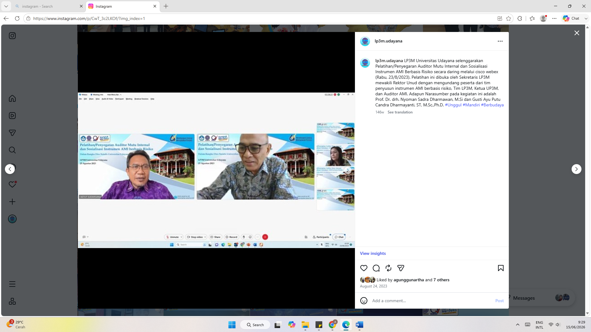
Instagram
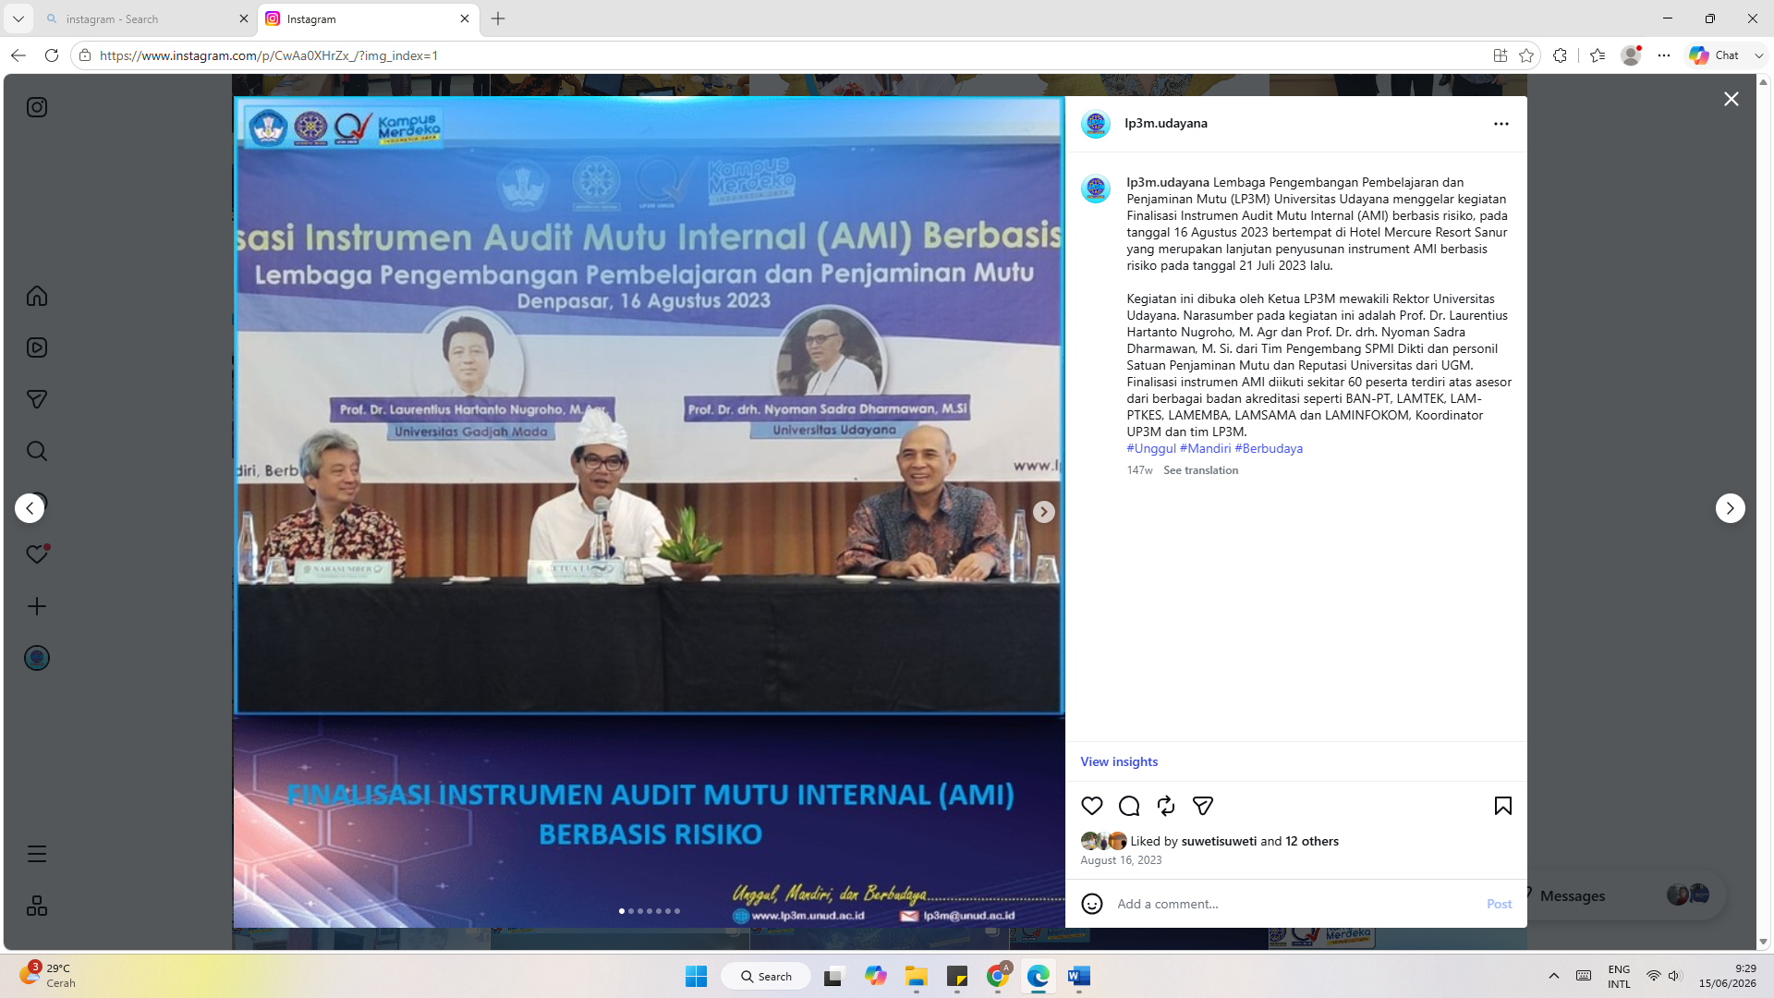
Instagram
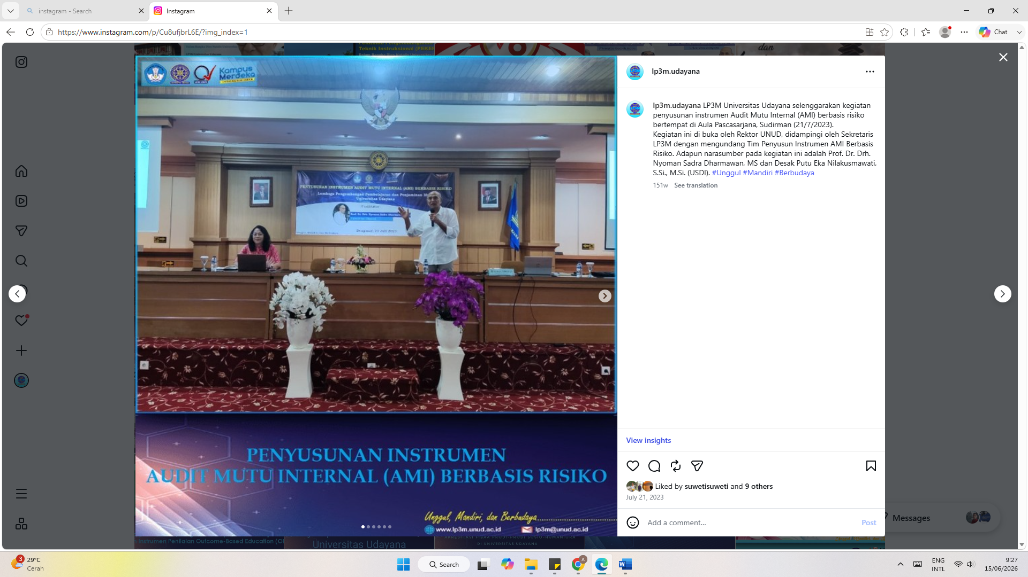
Instagram
